# **EISCAT EXPERIMENT**

**a) Why is pulse-to –pulse technique required both for coherent (ESRAD) and incoherent (EISCAT) parts in the experiment described in the paper?**

Pulse-to-pulse techniques are required both for ESRAD and EISCAT experiments so that Doppler Effect of the returned signal can be used to determine target's velocity. Hence, Doppler velocities can be determined using pulse to pulse techniques. The returned signal exhibits a phase shift from pulse to pulse due to shift in the position of reflector between each transmit pulse. As a result, Doppler modulation is produced on the reflected signal. Therefore, two different signals can be separated by using spread spectrum. Also, using pulses allows the radars to be used for long distances and for transmitting a high power pulse.

**b) In an ideal case, power can be estimated from ACF (0) or from the power spectrum. Explain the relationship between ACF (0) and power spectrum.**

In an ideal case, with zero noise, imaginary part becomes zero and the ACF becomes real.

The Eqn. A2 reduces to the relation between ACF (0) and power spectrum, from which power can be realized.

Relation between ACF (0) and power spectrum:

$$ACF(0)=\frac{1}{2π}\int{S\left(ω\right)dω}$$

**c) In the D-region, pulse-to-pulse measurements are taken to estimate the autocorrelation function. Why is it improper to determine the power from ACF (0) in this case? Why is it OK to determine ACF (τ) for τ≠0? HINT: Think about noise in p-t-p measurements of the ACF.**

As the noise is introduced in the pulse to pulse measurements of the ACF, some imaginary components will appear as a result.The real part of ACF (0) is determined by a decay (correlation) time which defines the spectral width. Accordingto Eqn. A3, each raw ACF has slightly different values due to the presence of the noise or Doppler shift, and such an averaging leads to incorrectly estimated spectral width for ACF (0).

Also, if the noise introduced in the measurements is white Gaussian in nature, then it will affect autocorrelation function most at zero time lag.

Hence for $ACF\left(τ\right) for τ≠0$ condition, using backgroundand wave parameters derived in the experimentEISCAT and ESRAD faculties modelled the effect of averaging ACFs over 5 s dumpson the resulting width of ACF magnitude which is Eqn. 4. That is why it is OK to determine power from ACF(τ) for τ≠0.

**d) How can you from the autocorrelation function and the power spectrum determine Doppler frequency fd and spectral width fs. Discuss the methods for a fit with n= 1 or 2 (Gaussian and Lorentzian), and for other values of n. Explain what to look for in principal and how it may be done numerically if needed.**

We already have autocorrelation function, the power spectrum (Eqn. A1, A2, A3) and relation between decay time and half-maximum half-width (Eqn. 4, 5, 6).

The Doppler frequency can be seen as the multiplication of ACF ($τ=0$) with an exponential part ${(\frac{τ}{τ_{c}})}^{n}$ in time domain. Hence, if we have well defined ACF, with Eqn. 4 and A3 Doppler frequency can be calculated. And with Eqn. 5 and 6 spectral width (fs) can be calculated.

Methods for a fit with n= 1 or 2 (Gaussian and Lorenzian), and for other values of n:

**Method 1 -** Averaging magnitude: In this technique, the absolute value of ACFs with time resolution is calculated and then averaged them over time. The ACFs real part contains more information with respect to the correlation time of signal because inside the PMWE layer the signal is stronger than the noise signal.

**Method 2 –** Complex Averaging: This method includes averaging of complex ACFs over the same time as in method 1 and then calculate the absolute values. After applying this method, the background noise was not found at the altitudes above PMWE layer. The imaginary components of ACF due to the noise of different signs compensate each other and the real half (due to signal) left.

ResultingACFs by a power function is defined as follows:

$$\ln\left(ACF\right)=x_{1}-{(\frac{τ}{x_{2}})}^{x_{3}}$$

Where, x1, x2 and x3 are estimates of ln (ACFτ=0), τc and n respectively. By minimizing the mean square error between the logarithm of the fitted and experimental ACFs, we get the best fit.

In principal, we are looking for the “Likeliness” of the observed values of ACF for PWME from the experiment with different values of ‘n’ numerically with Eqn.7 . When the nearest match is found with a specific value of ‘n’, for different regions, existing distributions are realized.

**e) Rewrite the final expression in Eq. (A.3) in the ideal case, when no noise is present**

The given equation A.3 is given as:

$${ACF}_{D}\left(τ\right)=[\cos\left(ω_{D}τ\right)Re+isin\left(ω_{D}τ\right)Im\left({ACF}_{D=0}\right)]+i[cos\left(ω_{D}τ\right)Im\left({ACF}_{D=0}\right)-isin\left(ω_{D}τ\right)Re\left({ACF}_{D=0}\right)]$$

In ideal case, when no noise is present, the imaginary part is zero. The equation can be re-written as:

$${ACF}_{D}\left(τ\right)=\cos\left(ω_{D}τ\right)Re\left({ACF}_{D=0}\right)-i.sin(ω_{D}τ)Re\left({ACF}_{D=0}\right)$$

**f) Sketch the ideal, noise free ACF from d), assuming that the ACF is a Gaussian. Explain.**

Considering ACF equation 4 from paper and comparing it with Gaussian distribution,

Gaussian distribution:

$$f(x)=\frac{1}{\sqrt{2πσ^{2}}}e^{\frac{-{(x-μ)}^{2}}{2σ^{2}}}$$

We set the parameters of ACF as mean ($μ$) = 0, & standard deviation (σ) = 1.

Hence, we defined,

$τ_{c}=\sqrt{2} σ=\sqrt{2}$.

**Code:**

Fs = 100; % Sampling frequency

t = -0.5:1/Fs:0.5; % Time vector

L = length(t); % Signal length

X = (1/(sqrt(2*pi)))*(exp(-t.^2/(2)));

plot(t,X)

title('Noise free Gaussian ACF in Time Domain');

xlabel('Time (t)');

gridon

ylabel('ACF(t)');

**Plot:**

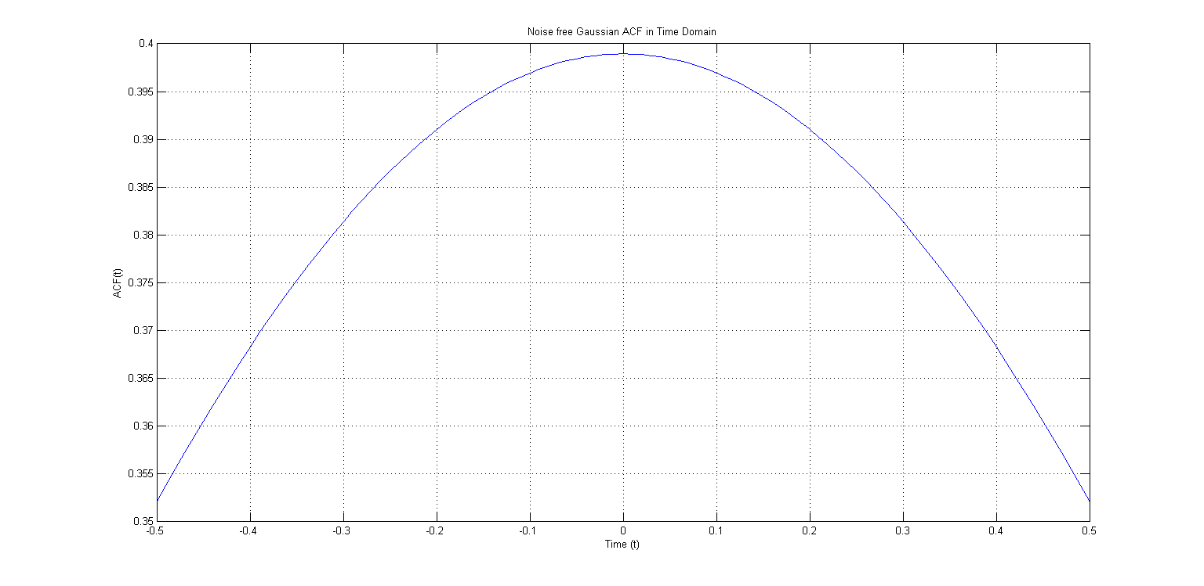

**Figure 1: Noise Free Gaussian ACF in Time Domain**

**g) Sketch the power spectrum of e) (in principal). Explain.**

Considering ACF function f) and eqn. (A1)

We take Fourier transform of ACF in order to get power spectrum.

**Code: (Continued from part f)**

n = 2^nextpow2(L);

power_spectrum = fft(X,n);

f = Fs*(0:(n/2))/n;

P = abs(power_spectrum/n);

figure;

plot(f,P(1:n/2+1))

title('Power Spectrum');

xlabel('Frequency (W)');

gridon

ylabel('Power');

**Note:** As we have to take Fast Fourier transform for computation of Fourier transform of ACF in order to get power spectrum, all the signals and plots were taken discrete in time domain.

**Plot:**

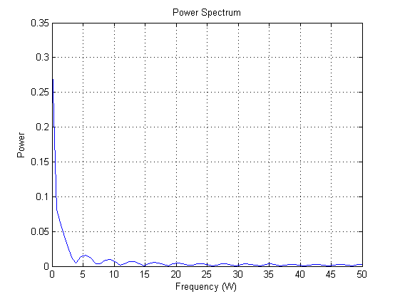

**Figure 2: Power Spectrum**

**h) Two methods are used to estimate the ACFD=0: complex averaging and averaging magnitude (Eq.(A.4)). When is it proper to use the different methods? Explain.**

**Method 1 -** Averaging magnitude: It is used inside the PMWE layer. In this technique, the absolute value of ACFs with time resolution is calculated and then averaged them over time. The ACFs real part contains more information with respect to the correlation time of signal because inside the PMWE layer the signal is stronger than the noise signal.

**Method 2 –** Complex Averaging: It is used to average the weak signals outside the PMWE layer. This method includes averaging of complex ACFs over the same time as in method 1 and then calculate the absolute values. After applying this method, the background noise was not found at the altitudes above PMWE layer. The imaginary components of ACF due to the noise of different signs compensate each other and the real half (due to signal) left.

# **ESRAD Experiment**

**i). Calculate the length of the full pulse (8 bits) in seconds.**

Range resolution ($∆R$) = 600m (from Table-2), c= 3 * 108

For 8 bits:

$$T_{P}=4* {10}^{-6}*8=32 μsec$$

**j) How long after the pulse is transmitted shall the receiver be opened? For how long shall it be open?**

The receiver should be opened at a time so that it can detect the received echo. The shortest distance for which we want to detect returned echo is 60 km.

$$t=\frac{2R_{1}}{c}=\frac{2×60×{10}^{3} m}{3×{10}^{8} m/sec}=0.4 msec=400 μsec$$

Therefore, the pulse will take $400 μsec$ to return back to the radar after being transmitted. Hence, the receiver should be opened before the pulse returns to the radar i.e. receiver should be opened, say $300 μsec,$ after the pulse is transmitted.

The receiver should be opened for a time so that it can detect the echo being returned from 80 km. Also, the receiver should be opened for the entire duration of the pulse length so it has sufficient time to sense the incoming signal.

$$t^{'}=\frac{2R_{2}}{c}-\frac{2R_{1}}{c}+\frac{2∆R}{c}=\frac{2}{c}.\left(R_{2}-R_{1}+∆R\right)=\frac{2}{3×{10}^{8} m/sec}×\left(80-60+0.6\right)×{10}^{3}m=0.137 msec=137 μsec$$

Therefore, the receiver should be opened for a little longer than $t^{'}$, $170 μsec$ say in order to ensure that the pulse is detected.

**k) You may calculate the maximum frequency for the spectral density function using the lag resolution. Do this calculation. Redo the calculation using other parameters from Table 1 or 2.**

The maximum frequency, $Δf_{max}$ is:

$${Δf}_{max}=\frac{1}{2T}$$

Where T is the lag resolution.

And From Table 2, the lag resolution, T= 24.6 msec, the maximum frequency is:

$${Δf}_{max}=\frac{1}{2T}=\frac{1}{2*24.6*{10}^{-3}}=20.325 Hz$$

**Note: k & l are same questions.**

**m) Calculate the maximum velocity (in m/s) that may be represented by the spectral density function.**

Velocity resolution is,

$$Δv=Δf_{max}* \frac{λ}{2}$$

Where $Δf_{max}$ is calculated above and $λ=\frac{c}{f}=\frac{3* {10}^{8}}{52* {10}^{6}}=5.769 m$

So,

$$Δv=Δf_{max}* \frac{λ}{2}=58.6298 m/sec$$

**n) 16 coherent integrations are used. Sketch the impulse response and the magnitude of the transfer function (DTFT) of the discrete LP-filter representing the integration. NOTE: You shall NOT calculate the transfer function, you shall only sketch it in principal and comment on the main characteristics of the transfer function of this type of filter.**

A low pass FIR filter of order 15 (as number of coherent integrations are 16) was taken in MATLAB Filter Design and Analysis Toolbox and filter coefficients were derived. These filter coefficients were then fed into a MATLAB program in order to plot impulse response and magnitude of DTFT. The MATLAB program used is given below:

x = [-0.02640 0.00650 0.04666 0.00692 -0.08075 -0.04874 0.17701 0.41448 0.41448 0.17701 -0.04874 -0.08075 0.00692 0.04666 0.00650 -0.02640];

t=[0 1 2 3 4 5 6 7 8 9 10 11 12 13 14 15]

figure

stem(t,x)

title('Impulse Response of Discrete Low Pass Filter')

xlabel('Time normalized with respect to sampling time')

ylabel('Amplitude')

X = fft(x);

N = 256;

X = fft(x, N);

w = 2*pi * (0:(N-1)) / N;

w2 = fftshift(w);

w3 = unwrap(w2 - 2*pi);

figure

plot(w3/(2*pi), abs(fftshift(X)))

title('Magnitude of the DTFT of Low Pass Filter')

xlabel('Frequency normalized with respect to sampling frequency')

ylabel('Amplitude')

hold on

Following are the plots of the impulse response and magnitude of DTFT for the discrete low filter representing 16 coherent integrations:

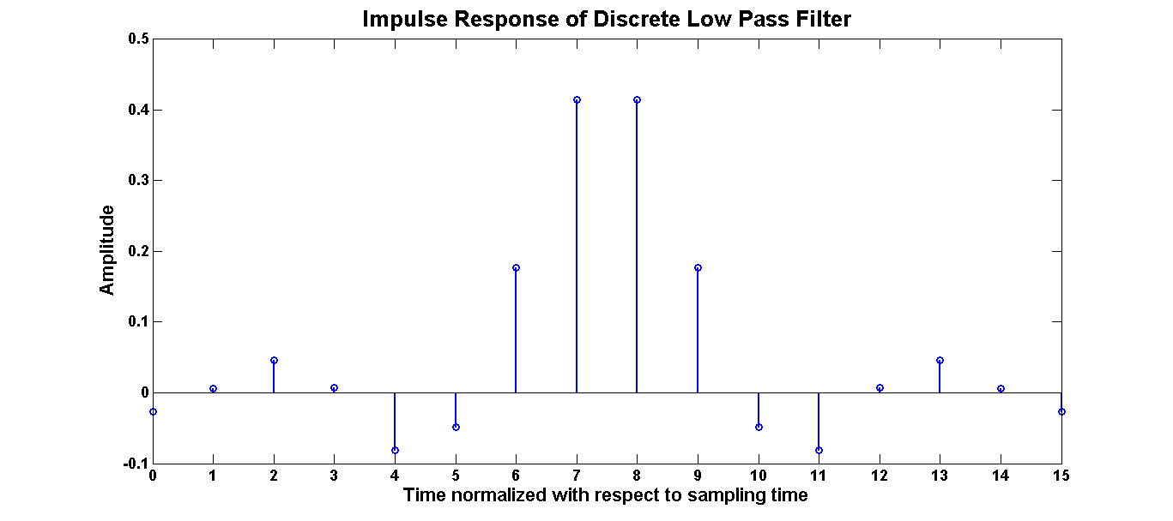

**Figure 3: Impulse Response of Discrete Low pass filter**

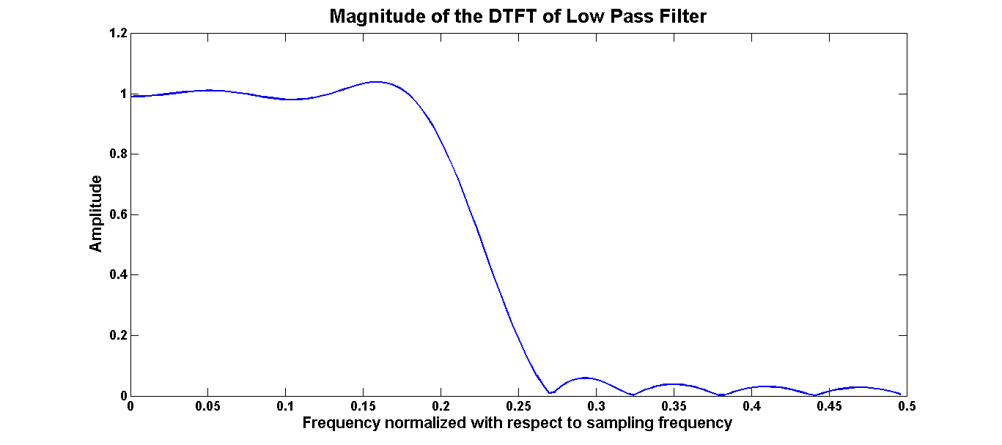

**Figure 4: Magnitude of the DTFT of Low pass filter**

As was expected, impulse response for the low pass filter is of the form of sinc function. Since 16 coherent integrations are used, we expect to have order of the transfer function of low pass filter as 15. It can be seen that there are some ripples in the passband as well as the stopband of the filter. Ripples in the passband indicates that probably we are using very high order filter with a steep roll off. Ripples in the stopband are a feature of the filter design we have used for calculating the filter coefficients. Low pass filter allows signals at low frequencies to pass and attenuates frequencies higher than the cutoff frequencies. Since low pass filter has an almost rectangular shape in frequency, we expect the impulse response in time to be of the form of sinc function.

**o) Barker code is not used in this experiment. Referring to the experiment purpose, would it be suitable to use Barker code? Explain your view.**

It is not suitable to use the Barker code because it only correlates at one instant whereas the complementary code uses two coded sequences which have side lobes of same size but opposite sign and it generally have large side lobe suppression than barker code.